1. Buka alamat

<https://adm-tpa.uin-alauddin.ac.id/>

1. Masukkan username sesuai pembagian ruangan

|  |  |  |  |
| --- | --- | --- | --- |
| No. | Username | Pass | Peserta |
| 1 | tpa01 | TPAUINAM | 200-414-00236  200-414-00235  200-414-00234  200-414-00233  200-414-00232  200-414-00231  200-414-00230  200-414-00229  200-414-00228  200-414-00227  200-414-00226  200-414-00225  200-414-00224  200-414-00223  200-414-00222  200-414-00221  200-414-00220  200-414-00219  200-414-00218  200-414-00217 |
| 2 | tpa02 | TPAUINAM | 200-414-00216  200-414-00215  200-414-00214  200-414-00213  200-414-00212  200-414-00211  200-414-00210  200-414-00209  200-414-00208  200-414-00207  200-414-00206  200-414-00205  200-414-00204  200-414-00203  200-414-00202  200-414-00201  200-414-00200  200-414-00199  200-414-00198  200-414-00197 |
| 3 | tpa03 | TPAUINAM | 200-415-00093  200-414-00196  200-415-00092  200-414-00195  200-415-00091  200-415-00090  200-415-00089  200-415-00088  200-414-00194  200-415-00087  200-414-00193  200-415-00086  200-415-00085  200-415-00084  200-415-00083  200-415-00082  200-414-00192  200-415-00081  200-415-00080  200-414-00191 |
| 4 | tpa04 | TPAUINAM | 200-415-00079  200-415-00078  200-415-00077  200-415-00076  200-414-00190  200-414-00189  200-415-00075  200-415-00074  200-414-00188  200-414-00187  200-415-00073  200-415-00072  200-414-00186  200-414-00185  200-414-00184  200-414-00183  200-414-00182  200-414-00181  200-414-00180  200-414-00179 |
| 5 | tpa05 | TPAUINAM | 200-414-00178  200-415-00071  200-415-00070  200-414-00177  200-415-00069  200-415-00068  200-414-00176  200-414-00175  200-415-00067  200-414-00174  200-414-00173  200-414-00172  200-414-00171  200-414-00170  200-414-00169  200-414-00168  200-415-00066  200-414-00167  200-415-00065  200-414-00166 |
| 6 | tpa06 | TPAUINAM | 200-414-00165  200-414-00164  200-415-00064  200-414-00163  200-415-00063  200-415-00062  200-415-00061  200-415-00060  200-415-00059  200-415-00058  200-415-00057  200-415-00056  200-415-00055  200-415-00054  200-415-00053  200-415-00052  200-414-00162  200-415-00051  200-414-00161  200-415-00050 |
| 7 | tpa07 | TPAUINAM | 200-414-00160  200-414-00159  200-414-00158  200-414-00157  200-415-00049  200-414-00156  200-414-00155  200-414-00154  200-415-00048  200-414-00153  200-414-00152  200-415-00047  200-414-00151  200-415-00046  200-415-00045  200-415-00044  200-414-00150  200-414-00149  200-414-00148  200-414-00147 |
| 8 | tpa08 | TPAUINAM | 200-414-00146  200-415-00043  200-414-00145  200-415-00042  200-415-00041  200-414-00144  200-414-00143  200-414-00142  200-415-00040  200-414-00141  200-414-00140  200-415-00039  200-415-00038  200-414-00139  200-415-00037  200-414-00138  200-414-00137  200-415-00036  200-414-00136  200-414-00135 |
| 9 | tpa09 | TPAUINAM | 200-414-00134  200-415-00035  200-414-00133  200-414-00132  200-415-00034  200-414-00131  200-414-00130  200-415-00033  200-414-00129  200-414-00128  200-415-00032  200-415-00031  200-414-00127  200-414-00126  200-414-00125  200-414-00124  200-414-00123  200-414-00122  200-414-00121  200-415-00030 |
| 10 | tpa10 | TPAUINAM | 200-414-00120  200-415-00029  200-414-00119  200-415-00028  200-414-00118  200-414-00117  200-414-00116  200-414-00115  200-414-00114  200-414-00113  200-414-00112  200-414-00111  200-414-00110  200-414-00109  200-414-00108  200-414-00107  200-414-00106  200-415-00027  200-414-00105  200-414-00104 |
| 11 | tpa11 | TPAUINAM | 200-414-00103  200-415-00026  200-414-00102  200-414-00101  200-414-00100  200-414-00099  200-414-00098  200-414-00097  200-414-00096  200-414-00095  200-415-00025  200-414-00094  200-414-00093  200-414-00092  200-415-00024  200-414-00091  200-414-00090  200-415-00023  200-414-00089  200-414-00088 |
| 12 | tpa12 | TPAUINAM | 200-414-00087  200-414-00086  200-414-00085  200-414-00084  200-415-00022  200-414-00083  200-414-00082  200-414-00081  200-415-00021  200-414-00080  200-414-00079  200-414-00078  200-414-00077  200-415-00020  200-414-00076  200-414-00075  200-414-00074  200-414-00073  200-415-00019  200-415-00018 |
| 13 | tpa13 | TPAUINAM | 200-414-00072  200-414-00071  200-414-00070  200-414-00069  200-414-00068  200-415-00017  200-415-00016  200-414-00067  200-414-00066  200-414-00065  200-414-00064  200-414-00063  200-414-00062  200-414-00061  200-415-00015  200-415-00014  200-414-00060  200-414-00059  200-415-00013  200-414-00058 |
| 14 | tpa14 | TPAUINAM | 200-414-00057  200-414-00056  200-414-00055  200-415-00012  200-415-00011  200-414-00054  200-415-00010  200-414-00053  200-414-00052  200-414-00051  200-414-00050  200-414-00049  200-414-00048  200-415-00009  200-414-00047  200-414-00046  200-415-00008  200-414-00045  200-414-00044  200-415-00007 |
| 15 | tpa15 | TPAUINAM | 200-414-00043  200-414-00042  200-414-00041  200-414-00040  200-414-00039  200-414-00038  200-414-00037  200-414-00036  200-414-00035  200-414-00034  200-414-00033  200-414-00032  200-415-00006  200-414-00031  200-414-00030  200-414-00029  200-414-00028  200-414-00027  200-414-00026  200-414-00025 |
| 16 | tpa16 | TPAUINAM | 200-414-00024  200-414-00023  200-414-00022  200-414-00021  200-414-00020  200-414-00019  200-415-00005  200-414-00018  200-414-00017  200-414-00016  200-414-00015  200-415-00004  200-414-00014  200-415-00003  200-414-00013  200-414-00012  200-414-00011  200-414-00010  200-414-00009  200-414-00008 |
| 17 | tpa17 | TPAUINAM | 200-414-00007  200-414-00006  200-414-00005  200-414-00004  200-415-00002  200-414-00003  200-414-00002  200-415-00001  200-414-00001  200-415-00094 |

1. Klik tombol Aktifasi Peserta

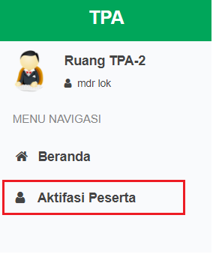

1. Untuk mengisi berita acara silahkan klik :

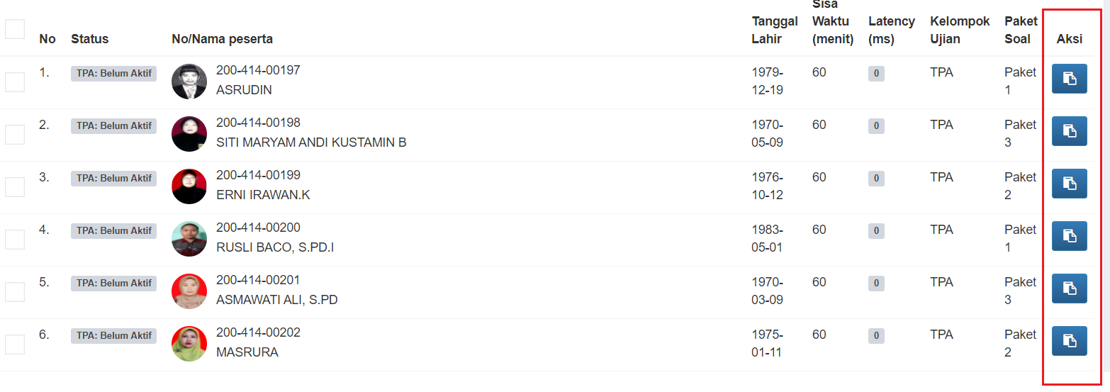

1. Silahkan centang berita acara, atau menambahkan catatan. Setelah itu klik simpan

